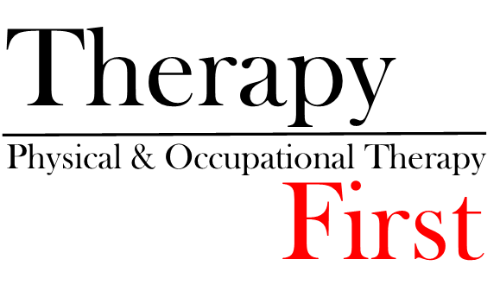

Integrative Dry Needling Consent Form

Integrative Dry Needling involves placing a small needle into the tissue that is tender with the intent to normalize the physiology of the area and regain homeostasis, which will improve the function of the musculoskeletal system resulting in symptom reduction.

Integrative Dry Needling is a valuable treatment for musculoskeletal pain. Like any treatment there are possible complications. While these complications are rare in occurrence, they are real and must be considered prior to giving consent to treatment.

Risks of the procedure:
Though unlikely there are risk associated with this treatment. The most serious risk associated with Dry Needling is accidental puncture of a lung (pneumothorax). If this were to occur, it may likely only require a chest x-ray and no further treatment. The symptoms of shortness of breath may last for several day to weeks. A more severe lung puncture can require hospitalization and re-inflation of the lung. This is a rare complication and in skilled hands should not be a concern.

Other risks may include bruising, infection, and nerve injury. Please notify your provider if you have any conditions that can be transferred by blood. Bruising is a common occurrence and should not be a concern unless you are taking a blood thinner. As the needles are very small and do not have a cutting edge, the likelihood of any significant trauma from Dry Needling is unlikely.

Please consult with your practitioner if you have any questions regarding the treatment above.

Do you have any known disease or infection that can be transmitted through bodily fluids?
YES _________ NO _________
If you marked YES, please discuss with your practitioner.

Please print your name

Signature Date

